Hi all,

Please follow the instructions in the python setup links.

[https://code.visualstudio.com/docs/python/python-tutorial](https://code.visualstudio.com/docs/pythonwwwwwwwwwwwwwwwwww/python-tutorial)

+++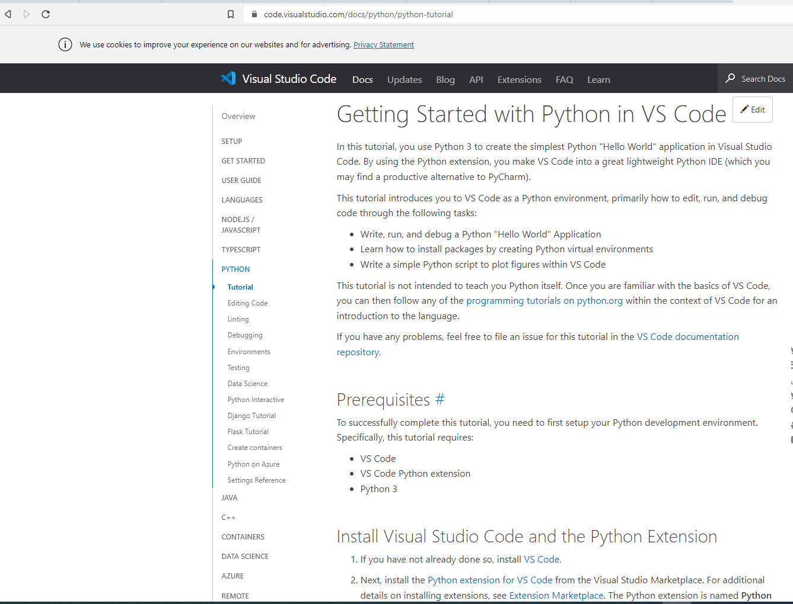

Please read the installation instructions carefully and instal the python interpreter (steps are further down in the document) too.

If you have issues with installation, please search on google with the issue and the version of your operating system and visual code.